**RUN AS SPRINGBOOT APPLICATION:**

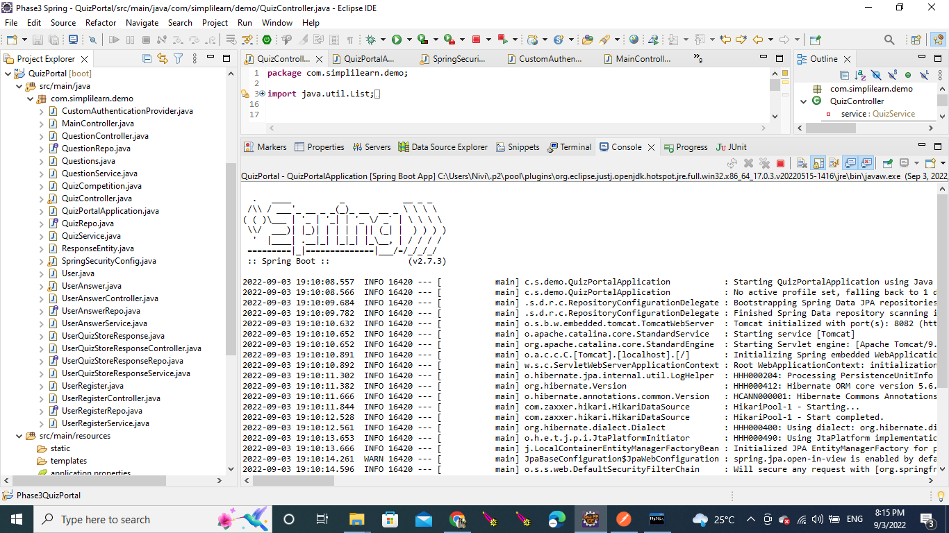

**WELCOME PAGE:**

**ADMIN PAGE:**

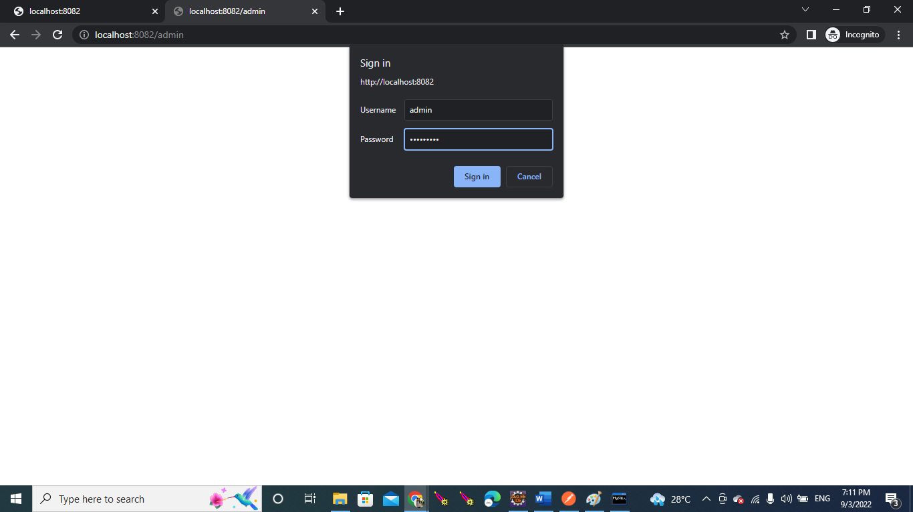

**USER LOGIN PAGE:**

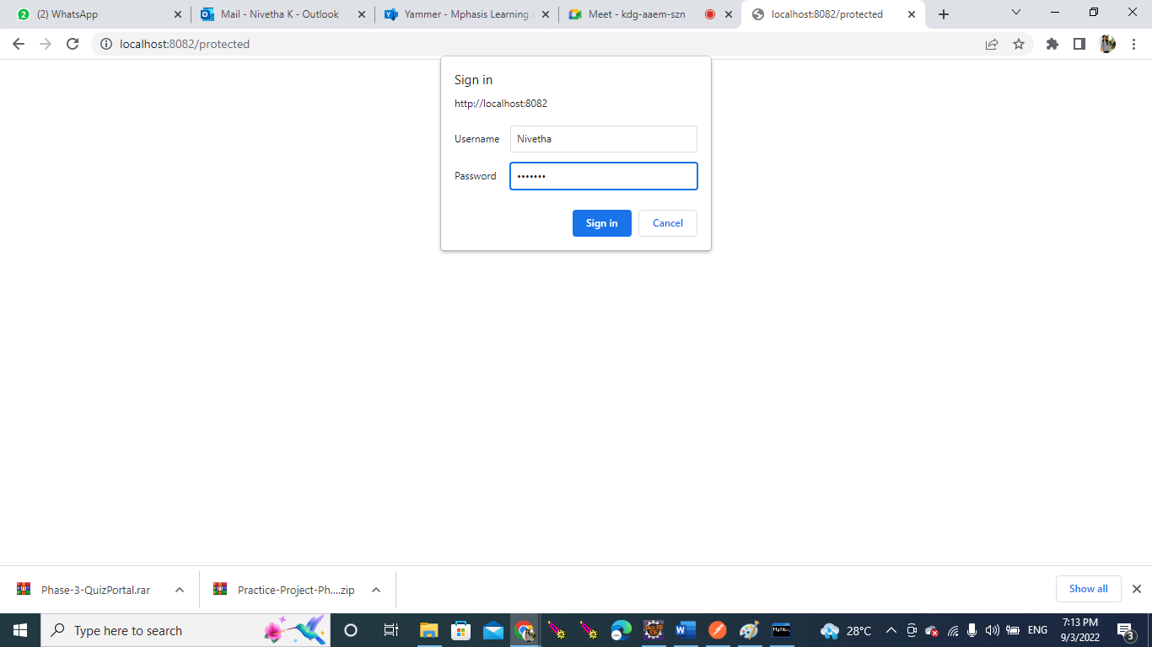

**USER REGISTERATION:**

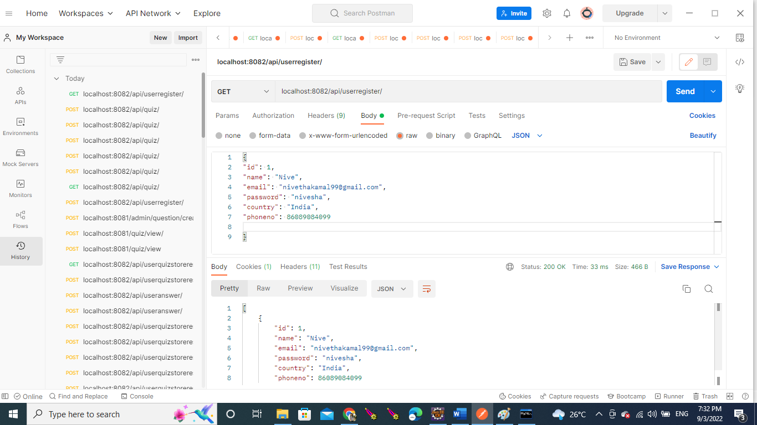

**DATABASE TABLE**

**TABLE NAME : user_register:**

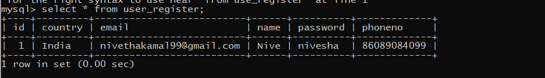

**DATABASE TABLES:**

**POSTING QUIZ ID AND QUESTION ID:**

Table Name: Quiz_Competition:

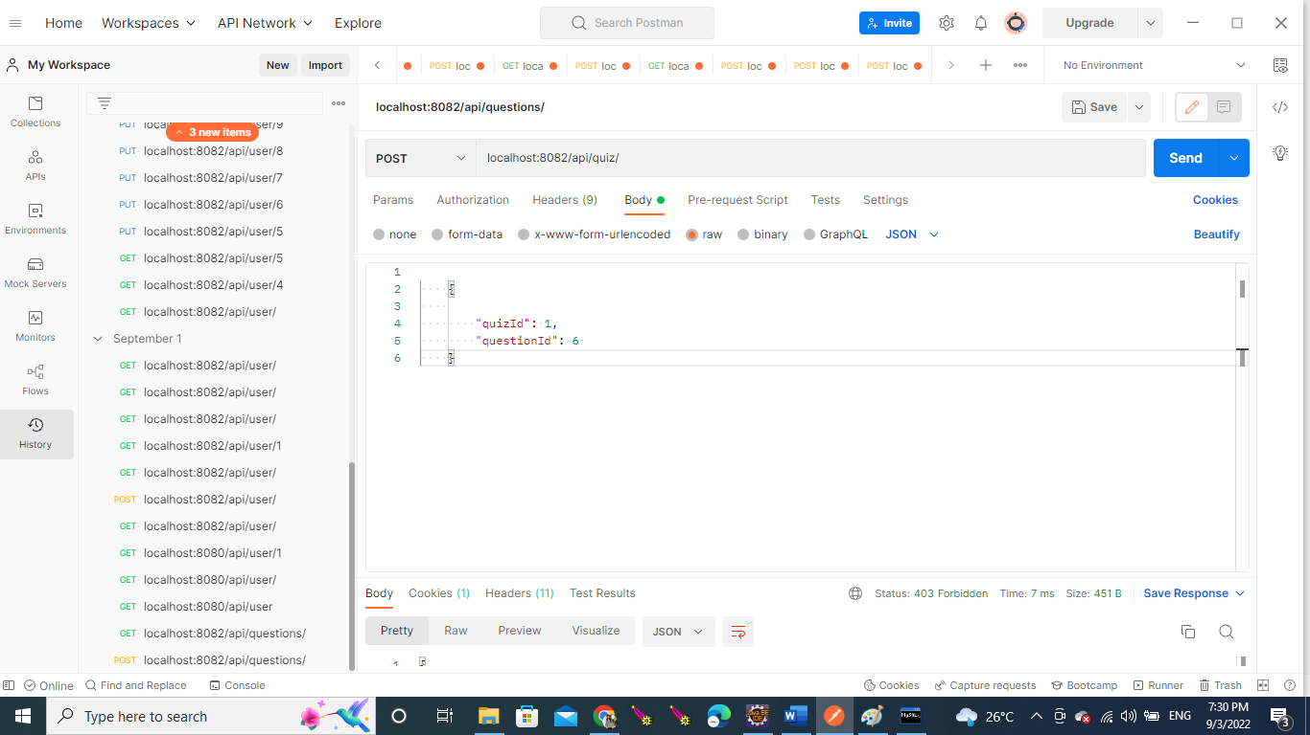

**GETTING QUIZ ID AND QUESTION ID:**

**DATABASE TABLE:**

**TABLE NAME : Quiz_Competition**

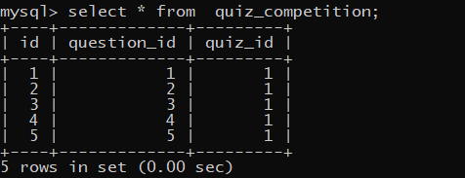

**POSTING QUESTION AND ANSWERS IN POSTMAN:**

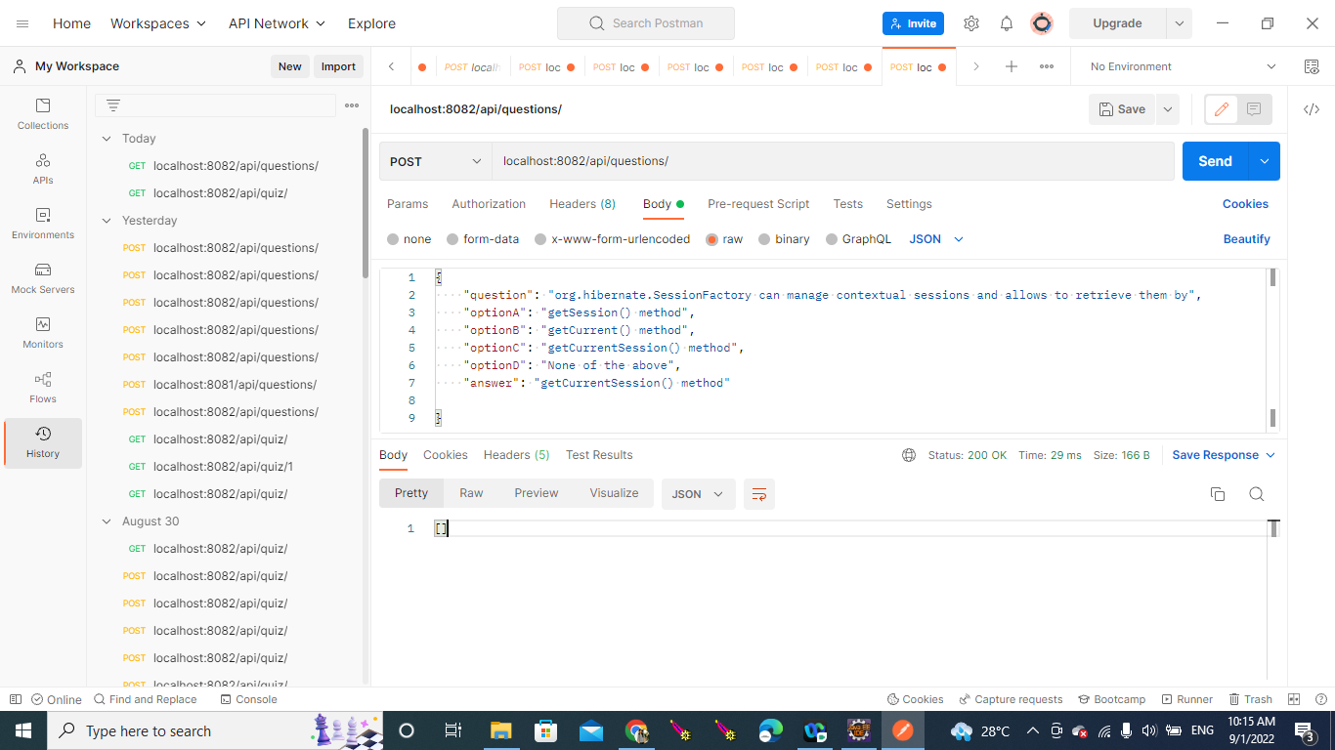

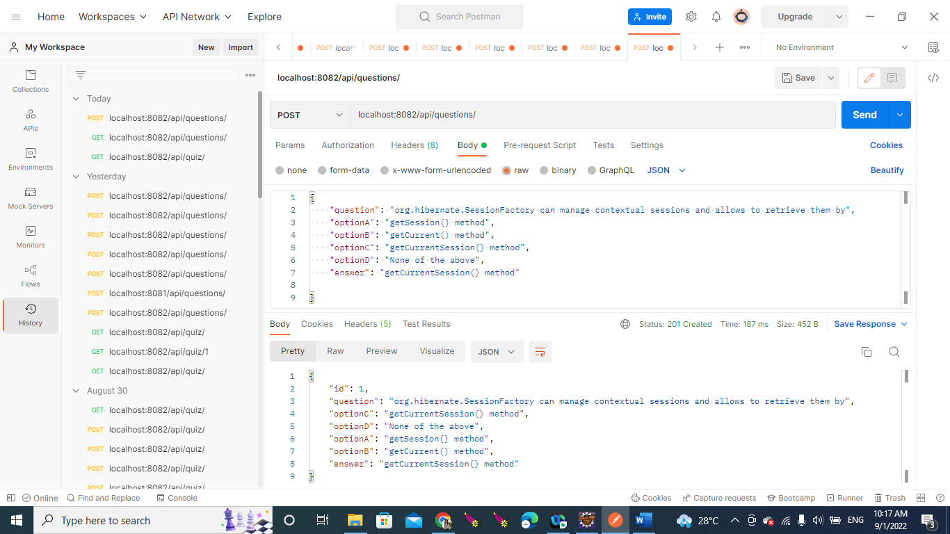

**GETTING QUESTION AND ANSWER:**

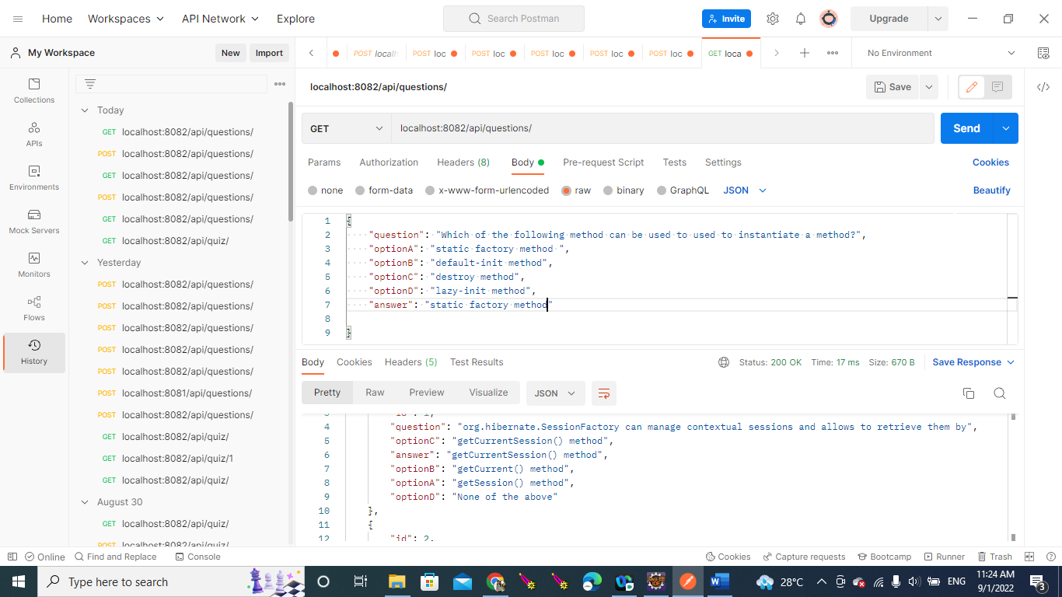

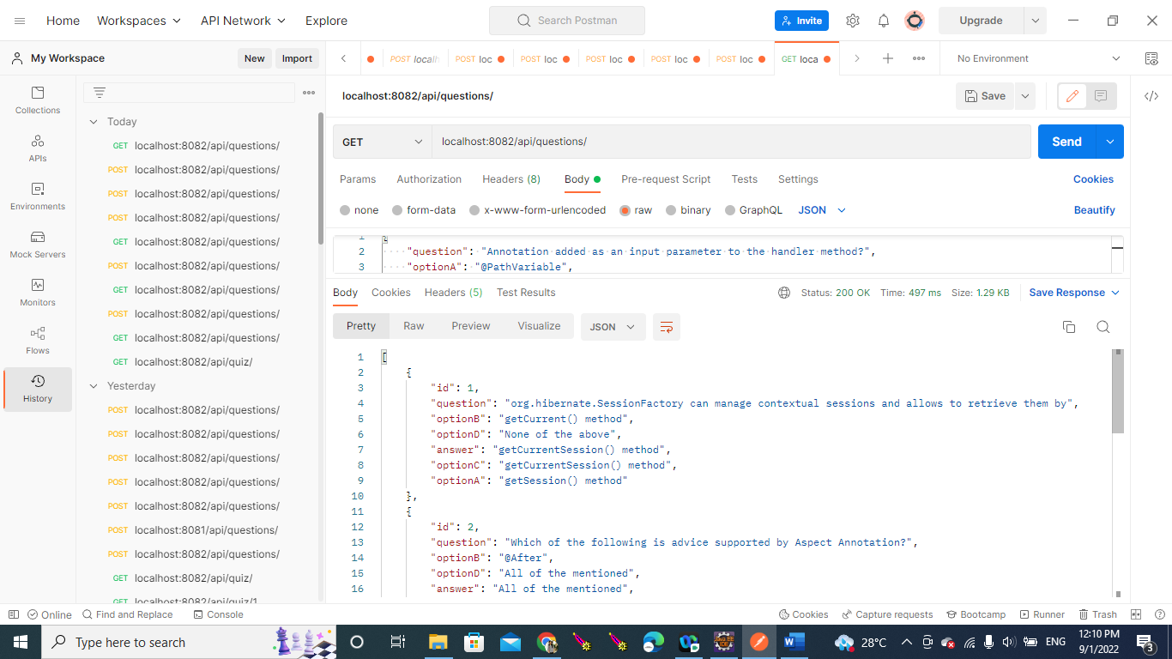

**TABLE NAME: Questions**

**POSTING USER ANSWER:**

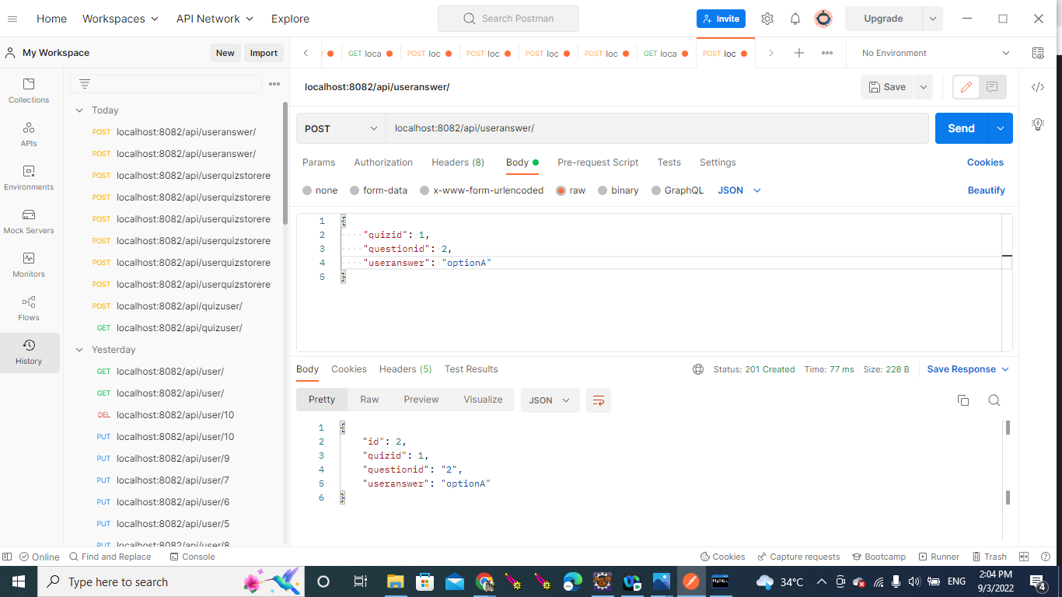

**GETTING USER ANSWER:**

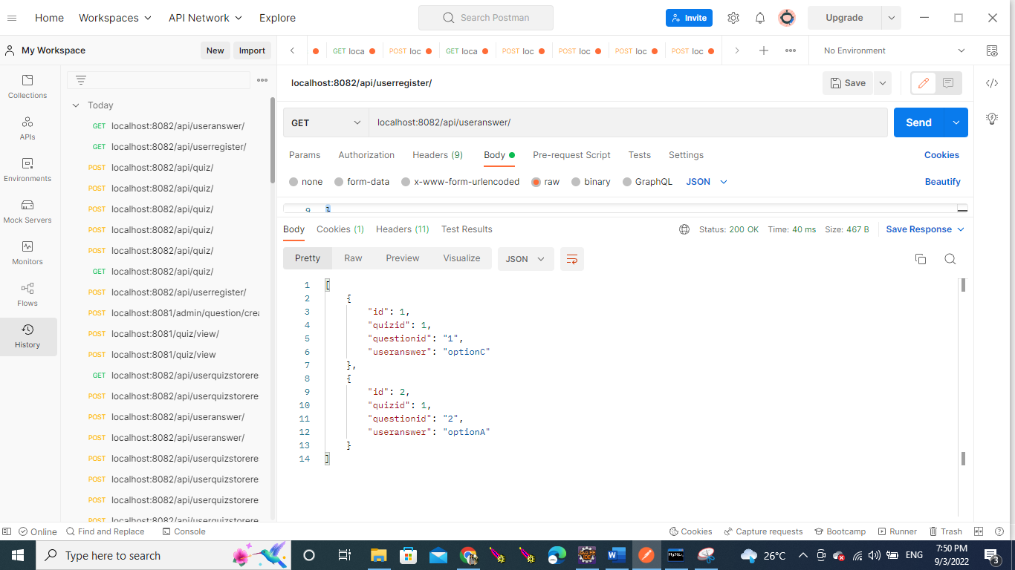

**DATABASE TABLE:**

**POSTING USER RESPONSE**

**TABLE NAME: user_quiz_store_response**

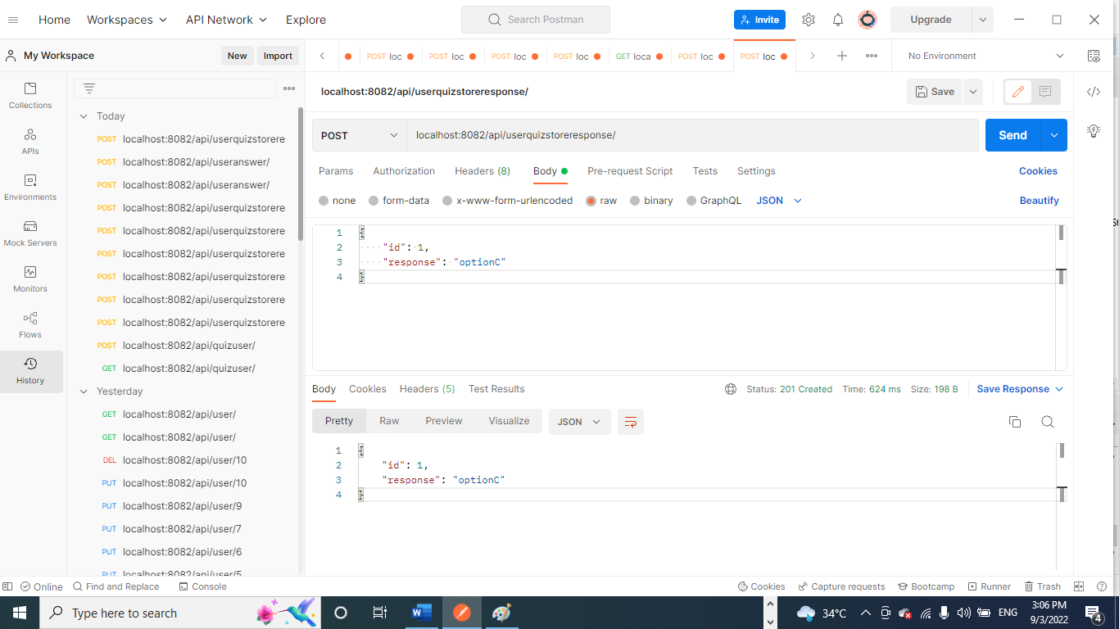

**GETTING USER RESPONSE:**

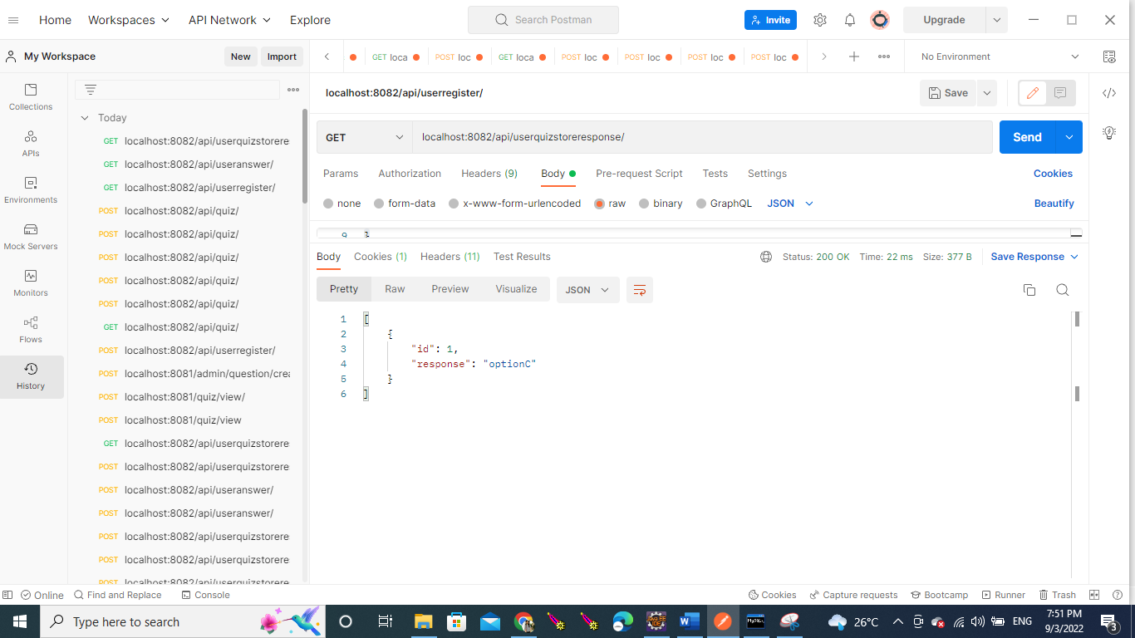

**DATABASE TABLE:**

